**GROUP PROJECT, GROUP 3**

**DATE: 29 October 2018**

**TIME: 10:00 – 13:00**

**ATTENDEES** Tom Gibbs, Henry Crofts

**LOCATION:** A216, ATRIUM

**Minute Taker: Tom Gibbs**

**Item One: Postmortem of previous week**

**What went well**

Team communication. Both members have been aware of each other’s availability, completion of work and task priorities through almost constant communication in person, in formal meetings and through discord messages.

Studio jam sessions continued to help team effectiveness in terms of quality of work, shared team understanding of work and efficiency of task completion.

Advice received from arranging tutor feedback sessions has been fundamental to the team’s prioritization of tasks and each week has helped to keep the project focused on strengthening weak elements.

Tutor advice has extended to recommending reading material and relevant videos which have provided design theories applicable to the specific issues team has encountered. Allowing the team to apply these theories to overcome these challenges.

Team members were able to contribute far more than the expected number of hours to achieve task results that were more polished than would have been if operating under a strict 12-hour work sprint.

**What went badly**

Team significantly underestimated the time needed to complete both a Game Design Document and Game Risk Assessment. While the design document was completed, and the majority of the risk assessment produced, team members needed to contribute far more than the expected number of hours to do so.

**Feedback received**

Rob via sprint review email reminded the team that tasks should also detail the work expected from completion the tasks (this sprint team had overlooked specifying this in the JIRA sprint.

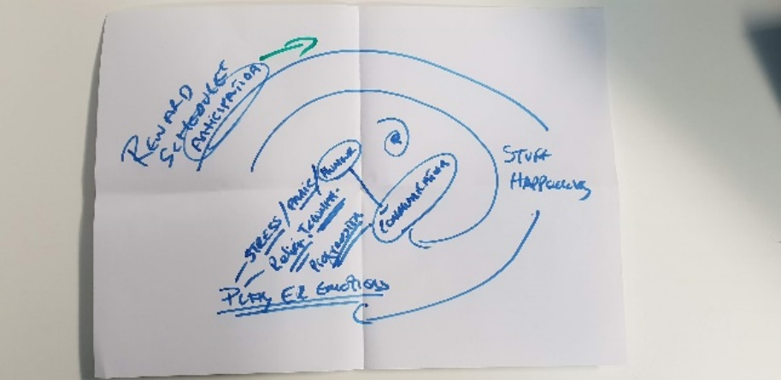Rob’s group project session: Rob began session by revisiting design theory underpinning the project design. Explaining how well-designed reward schedules create anticipation, then, through gameplay players experience emotional rewards and material rewards.

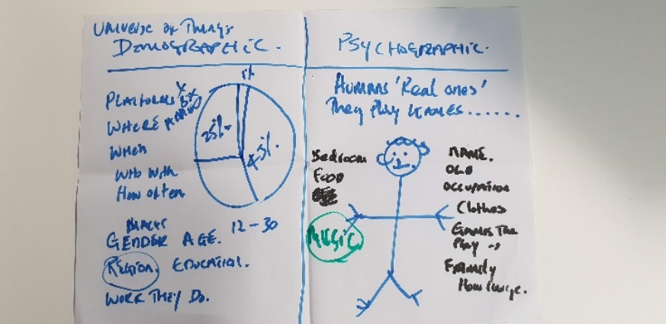This cycle locks players into the game, becoming tighter and tighter with each cycle – anticipation of emotions/material reward hooking them. (Rob specified that emotions are not rewards themselves).

Rob described the importance of having a defined and evidenced demographic and psychographic, and the relationship between them. Demographic – proportionate size of market you are aiming at. The issue with this breakdown is that proportional market shares do not play games, people do. Psychographic – a specific example of a member of the target demographic. A designer should know everything about their psychographic to enable them to design a game the psychographic will love. They must be thought of and how they will receive each design choice at every stage of the project.

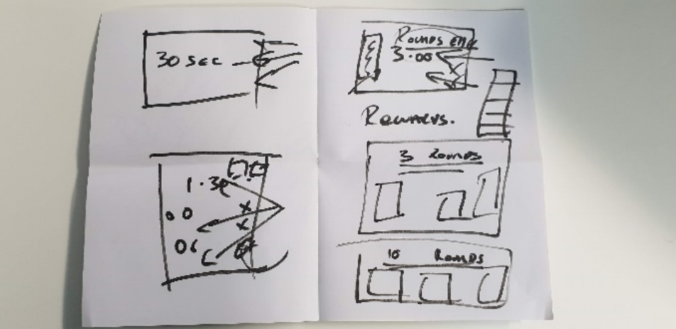Rob reminded the team that if they follow this design rule, team should not be disheartened if in playtesting reveals some players dislike the game – “it isn’t about everyone liking/disliking it, it’s all about your psychographic loving it”.

Rob went on to explain how different teams will be at different stages and the presentation guide is only that – a guide. Each team can use this to produce their own development milestones. Rob explained that if the team has focused on design, that boards showing the game scene over various intervals will be as effective as a recording of gameplay.

Dan’s group project session: Dan was pleased with the management style of the group and was pleased to hear the team had found jam sessions useful in quality of work completed, shared understandings of work and overall efficiency.

Dan reviewed design document produced by team, confirming it appeared to be of the appropriate format and contents. Dan did advise that the format of the document could be improved with sub-headings and a contents page (team will reformat the design document as per this advice this sprint). Team requested specific feedback as programmers have not been exposed to design documents and risk assessments before. Dan is happy to review both these documents when completed by the team (send to [d.mayers@uos.ac.uk](mailto:d.mayers@uos.ac.uk)). Discussion moved to the accompanying risk assessment which is yet to be completed. Dan advised that this documents contents should be colour coded as a visual aide (red denoting high risk elements, green low risk elements). Dan went on to explain that this information can then be populated into an excel spreadsheet to be broken down further using the following template table:

|  |  |  |  |
| --- | --- | --- | --- |
| **Risk Description** | **Likelihood** | **Impact on project** | **High/Med/Low** |
| Risk #1 | High | Low |  |
| Risk #1 | Med | Med |  |

Using the same colour coding, the final column is made from a combination of all previous columns and is the most accurate representation of the threat each risk poses.

Design document and Risk assessment should be revisited and updated over the duration of the project (as designs change and risks are mitigated/eliminated).

**How the next sprint can be improved**

Ensuring all JIRA tasks specify the work expected on completion of tasks.

Reformatting of the design document and risk assessments already produced to give team and shareholders more intelligible information.

Continue to use tutor feedback to help form sprint tasks.

**Individual work completed in previous sprint:**

**Tom:**

* Spend time in the labs as a team in a game jam / studio environment to increase team efficiency
  + **8h Estimated – 8h 15m Logged**
* Meet with Rob Kurta
  + **45m Estimated – 40m Logged**
* Meet with Chris Janes
  + **30m Estimated – 1h Logged**
* TASK AMENDED: Continue working on Design Document
  + **1h Estimated – 3h 30m Logged**
* Write a design document for the management game
  + **1h Estimated – 3h 30m Logged**
* Look into "Guns of Icarus" and find any design choices that could improve our game
  + **45m Estimated – 25m Logged**
* **Total estimated time: 12h - Total time logged: 17h 20m**

**Henry:**

* Spend time in the labs as a team in a game jam / studio environment to increase team efficiency
  + **8h Estimated – 8h 15m Logged**
* Meet with Rob Kurta
  + **45m Estimated – 40m Logged**
* Meet with Chris Janes
  + **30m Estimated – 1h Logged**
* Write a risk assessment document involved within the game and how the team plans to mitigate the risks
  + **1h Estimated – 1h Logged**
* TASK AMENDED: Continue working on risk assessment
  + **1h Estimated – 1h 30m Logged**
* Look into "Pixel Piracy" and find any design choices that could improve our game
  + **45m Estimated – Unable to log time for task (team were made aware in advance)**
* **Total estimated time: 12h - Total time logged: 12h 30m**

**Overall aims of the current sprint *(Detailed tasks, user stories and time allocations are tracked on JIRA)***

* Define demographic, with cited statistics
* From demographic, define psychographic
* Review scope of project
* Amend and reformat design document
* Amend and reformat risk assessment
* Continue to attend studio jam sessions for team efficiency and clarity
* Book tutor meetings to review progress and project design
* Populate JIRA with backlog of User Stories to achieve MVP
* Edit model/produce models of game elements which are essential for main game mechanics

**Meeting:**

All team present.

Team met after group feedback sessions with Dan and Rob to review their feedback. Team agreed that the advice received from tutors was extremely beneficial and should be used as the basis for plotting JIRA tasks for the current sprint.

In the previous sprint the team scheduled a meeting with Dave (today @ 14:45) to get feedback on the game’s design.

Team drafted a brief outline of tasks for the coming sprint, aware that feedback from Dave would also influence priorities this sprint.

Task list includes risk assessment improvements as per Dan’s feedback as well as tasks to evidence the teams chosen demographic and psychographic as per Rob’s feedback.

Team agreed to break for lunch, before re-joining at 14:00 to discuss the project design and project direction in preparation for Dave’s tutor session.

Following Dave’s feedback session team will confirm sprint tasks and begin work.

**Tom is responsible for meeting minutes and population of JIRA tasks this sprint.**

**Tasks for the current week:**

**Tom (13h):**

* **As suggested by Dan spend time in the labs as a team in a game jam setting to increase team efficiency (6h)**

Dan Mayers agreed that we would benefit from spending time together in the labs to work together in a game jam / studio environment especially during the design phase.

Team will use this time to respond to Dave’s feedback, redefining the project scope and making sure design choices are still appropriate.

* **Amendment of the Design Document - to be completed as team (1h)**

Team must edit the design document as per the recent design updates to ensure mutual understanding and clarity to shareholders.

* **Define Demographic - to be completed as team (1h)**

Team must provide evidence supporting the design’s established target market. Upload word document to group repository.

* **Define Psychographic - to be completed as team (1h 30m)**

Team must produce an example member from the target demographic to aide and inform in the future design choices of the projects future. Upload word document to group repository.

* **Ship model must be edited as per the design document to allow suitable area for player interaction (2h)**

Edit low poly shit model allowing for player movement on the deck, with restricted and raised pathways as drafted in meetings and detailed in the design document. Upload model to group repository.

* **Bucket model must be produced as per the needs of the design document to allow for player interaction (30m)**

Produce low poly bucket model, suitable for receiving material colour in Unity. Upload model to group repository.

* **Mop model must be produced as per the needs of the design document to allow for player interaction (20m)**

Produce low poly mop model, suitable for receiving material colour in Unity. Upload model to group repository.

* **Torch model must be produced as per the needs of the design document to allow for player interaction (20m)**

Produce low poly torch model, suitable for receiving material colour in Unity. Upload model to group repository.

* **Barrel model must be produced as per the needs of the design document to allow for player interaction (20m)**

Produce low poly barrel model, suitable for receiving material colour in Unity. Upload model to group repository.

**Henry (13h 30m Hours):**

* **As suggested by Dan spend time in the labs as a team in a game jam setting to increase team efficiency (6h)**

Dan Mayers agreed that we would benefit from spending time together in the labs to work together in a game jam / studio environment especially during the design phase.

Team will use this time to respond to Dave’s feedback, redefining the project scope and making sure design choices are still appropriate.

* **Amendment of the Design Document - to be completed as team (1h)**

Team must edit the design document as per the recent design updates to ensure mutual understanding and clarity to shareholders. Upload word document to group repository.

* **Define Demographic - to be completed as team (1h)**

Team must provide evidence supporting the design’s established target market. Upload word document to group repository.

* **Define Psychographic - to be completed as team (1h 30m)**

Team must produce an example member from the target demographic to aide and inform in the future design choices of the projects future. Upload word document to group repository.

* **Complete production of Risk Assessment (2h)**

Continue assessment of project risks, upload word document to group repository.

* **As per Dan Mayers feedback, reformat Risk Assessment into Excel spreadsheet (2h)**

Import Risk assessment into Excel document as per Dan’s feedback, to detail risk impact and allow for future revisions. Upload Excel document to group repository.

***Detailed tasks, task descriptions, user stories and time allocations are tracked on JIRA.***